Specification
of
CD PORTFOLIO System
Duleendra Shashimal
Email: shashimald@gmail.com Tel: +6598150006

Table of Contents

Introduction.............................................................................................................................. 3
Architecture Pattern of the System............................................................................ 3
Reasons to use MVC.................................................................................................... 3

System Architecture ................................................................................................................ 4
Sub Systems …............................................................................................................. 4
Actors and Use Cases of the System........................................................................... 4
Actors............................................................................................................... 4
Use Cases of the System................................................................................. 5
Class Diagram Of the System …............................................................................... 6
Entity Relationship Diagram of the System............................................................. 7

System Development............................................................................................................... 8
Development Framework........................................................................................... 8

Introduction

The architecture of the system has been designed by refereeing to the smiler system provided in the assignment (Captools). To get an clear idea about the business domain I followed that system documentation.

Since fund management operations based in Singapore, Sydney and Malaysia, CD PORTFOLIO system should be able to access from those countries. Therefore this system will be implemented as a web application.

Architecture Pattern of the System

This system will follow the MVC (Model View Controller) design pattern.

Reasons to use MVC

This is a system, which is suppose to do various business transactions, calculations etc. So separating all the business logics to a different layer will help to maintain the system easily. Also these business logics can be used form different presentation tires.

Since this is a web application , MVC pattern is the most suitable pattern because It will give a clear separation for Model, Views and Controller layers.

System Architecture

Sub Systems

CD PORTFOLIO system has divided into five sub systems.

- Client and Accounts
- Securities
- Portfolios
- Reports
- User Administrator

Actors and Use Cases of the System

Actors

- System Administrator: has rights for all the modules in the system.
- Client and Account Manager: assigned for the Client and Account module.
- Portfolio Manager: assigned for the Portfolio module
- Security Manager: assigned for the Security module.

Use Cases Diagram of the System

Following use case diagram shows the main actors and their interactions with the system.

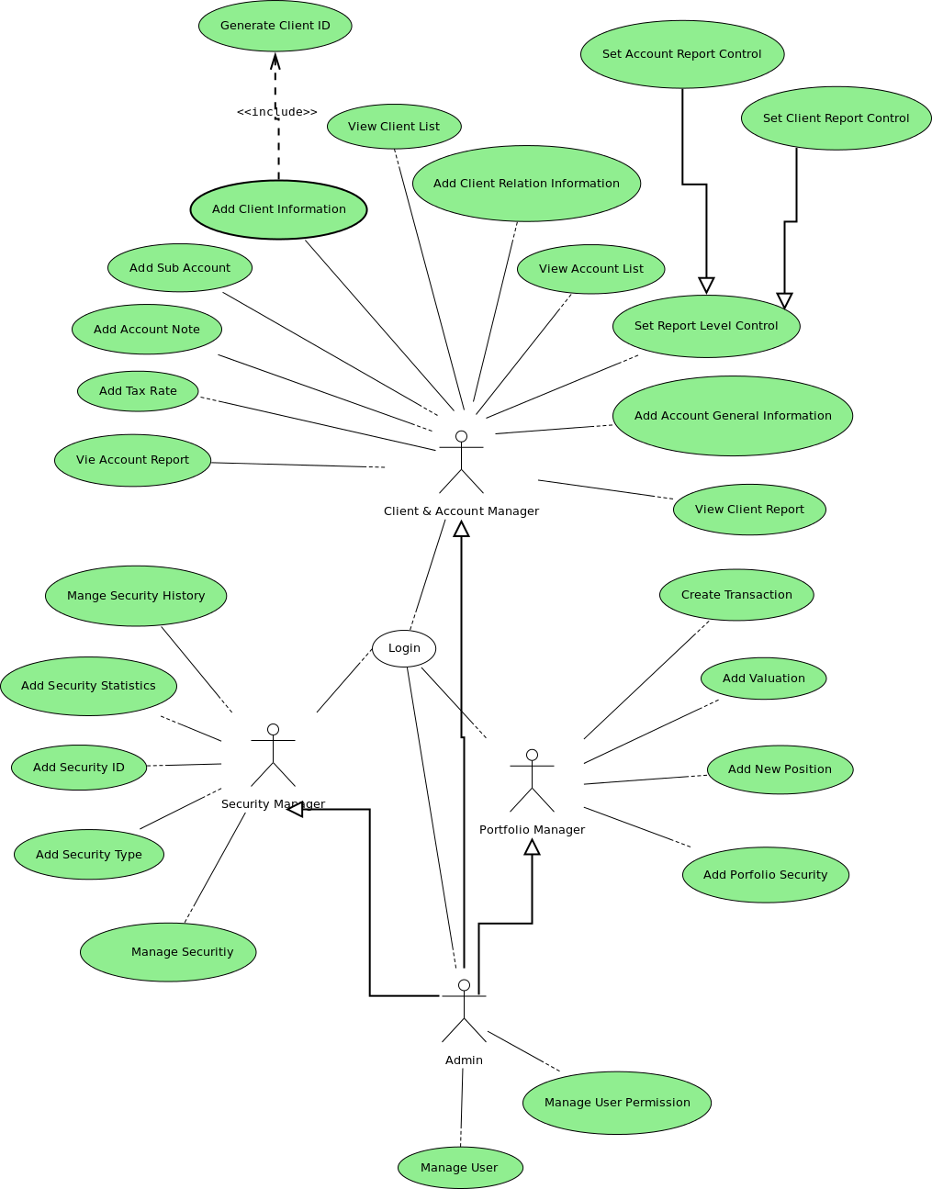
Main Use Case Diagram
Class Diagram Of the System

Following class diagram shows the static view of the system.
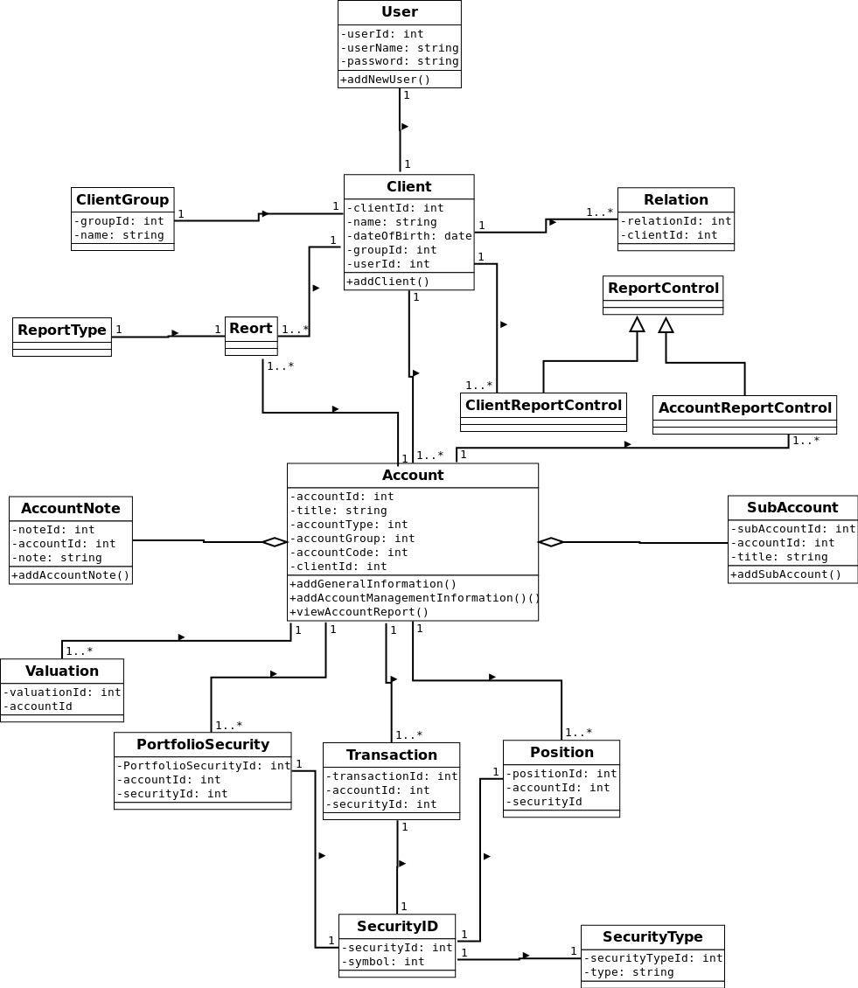
Class Diagram

Entity Relationship Diagram of the System

Following is the ER diagram of the system. It shows the main entities of the database and their relationships.

Note: Since the diagram get complicated,only the primary key and foreign key attributes included.

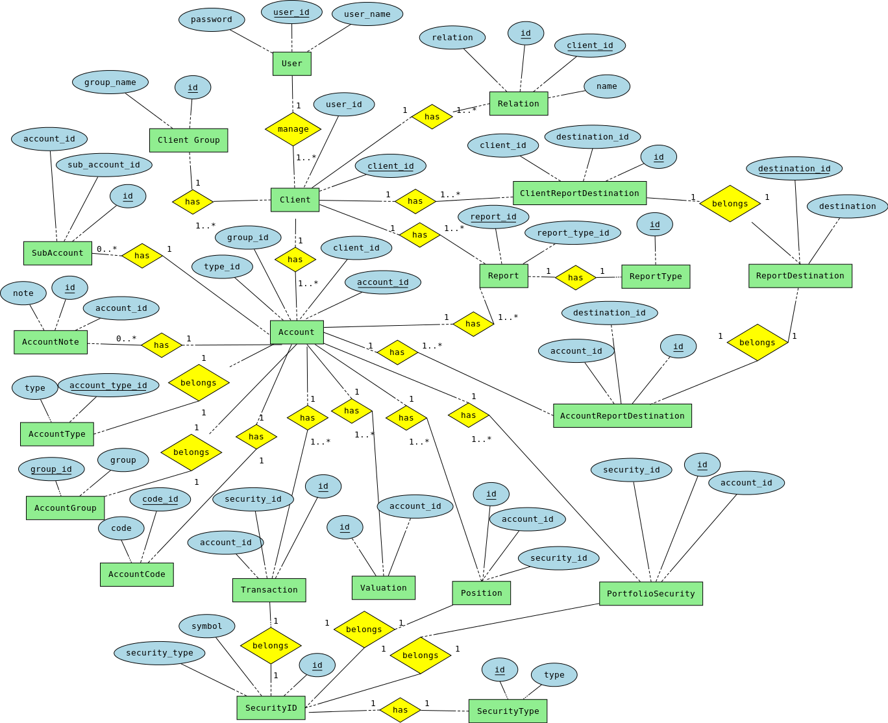

System Development

Development Framework

As proposed system follows the MVC pattern , selected frame work should be able to implement the MVC design pattern.

Also selected framework should support for the rapid application development.

Following are the best PHP frameworks which support to implement the MVC pattern.

- CakePHP
- Symfony
- Zend
- CodeIgniter
- YII

Each framework has pros and and cons. However Symfony and CakePHP are the best candidates for the proposed system.

As far as our business domain is concerned , Symfony has more advantages over CakePHP. Therefore Symfony framework should be used to develop the system.

Main Advantages of Symfony Framework

- ORM (Object Relational Mapping) using Doctrine Framework
- Doctrine Query Language for writing queries efficient and easily .
- High security features.
- Independent from database driver (can migrate to any database driver easily) Eg: From MySQL to Oracle.

